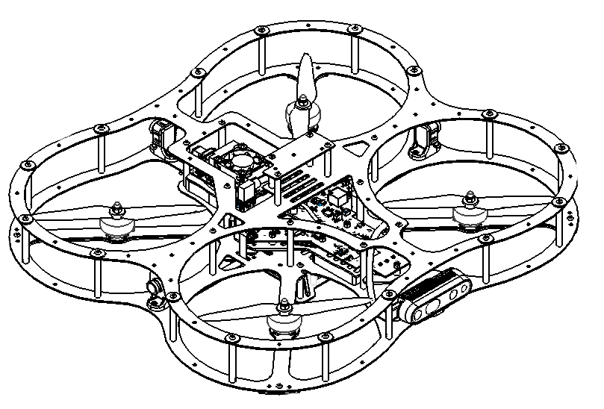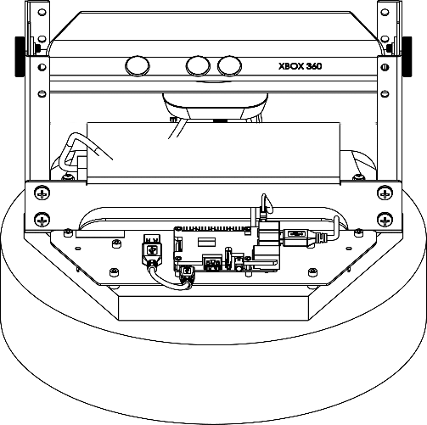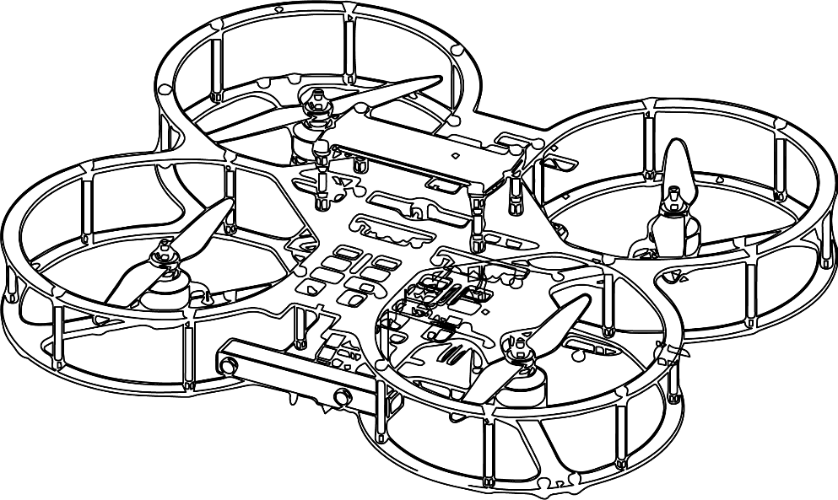

**Autonomous Vehicles Research Studio**

Setup Guide – Optitrack Camera Hardware

© 2023 Quanser Inc., All rights reserved

For more information on the solutions Quanser Inc. offers,   
please visit the web site at: <http://www.quanser.com>

|  |  |
| --- | --- |
| Quanser Inc.  119 Spy Court  Markham, Ontario  L3R 5H6, Canada | info@quanser.com  Phone : 19059403575  Fax : 19059403576  printed in Markham, Ontario. |

This document and the software described in it are provided subject to a license agreement. Neither the software nor this document may be used or copied except as specified under the terms of that license agreement. Quanser Inc. grants the following rights: a) The right to reproduce the work, to incorporate the work into one or more collections, and to reproduce the work as incorporated in the collections, b) to create and reproduce adaptations provided reasonable steps are taken to clearly identify the changes that were made to the original work, c) to distribute and publicly perform the work including as incorporated in collections, and d) to distribute and publicly perform adaptations. The above rights may be exercised in all media and formats whether now known or hereafter devised. These rights are granted subject to and limited by the following restrictions: a) You may not exercise any of the rights granted to You in above in any manner that is primarily intended for or directed toward commercial advantage or private monetary compensation, and b) You must keep intact all copyright notices for the Work and provide the name Quanser Inc. for attribution. These restrictions may not be waved without express prior written permission of Quanser Inc.

**FCC Notice** This device complies with Part 15 of the FCC rules. Operation is subject to the following two conditions: (1) this device may not cause harmful interference, and (2) this device must accept any interference received, including interference that may cause undesired operation.

**Industry Canada Notice** This Class A digital apparatus complies with Canadian ICES-003. Cet appareil numérique de la classe A est conforme à la norme NMB-003 du Canada.

**Waste Electrical and Electronic Equipment (WEEE)**

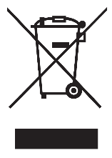This symbol indicates that waste products must be disposed of separately from municipal household waste, according to Directive 2002/96/EC of the European Parliament and the Council on waste electrical and electronic equipment (WEEE). All products at the end of their life cycle must be sent to a WEEE collection and recycling center. Proper WEEE disposal reduces the environmental impact and the risk to human health due to potentially hazardous substances used in such equipment. Your cooperation in proper WEEE disposal will contribute to the effective usage of natural resources.

|  |  |
| --- | --- |
|  | This product meets the essential requirements of applicable European Directives as follows:   * 2006/95/EC; Low-Voltage Directive (safety) * 2004/108/EC; Electromagnetic Compatibility Directive (EMC)   **Warning**: This is a Class A product. In a domestic environment this product may cause radio interference, in which case the user may be required to take adequate measures. |
| caution.png **Caution** | **This equipment is designed to be used for educational and research purposes and is not intended for use by the public.** The user is responsible to ensure that the equipment will be used by technically qualified personnel only. While the end-effector board provides connections for external user devices, users are responsible for certifying any modifications or additions they make to the default configuration. |

Table of Contents

A. Mounting Cameras 3

B. OptiHubs 5

C. Other Camera Solutions 7

D. Checkpoint – Localization System Picture 8

# A. Mounting Cameras

The **Autonomous Vehicles Research Studio** standard configurations include the Optitrack Flex 13 (Figure 1) camera solution. The number of vehicles involved directly affects the number of cameras required, the required minimum size of the room, and the corresponding approximate size of the volume captured by the cameras (Table 1).

|  |  |  |  |  |  |
| --- | --- | --- | --- | --- | --- |
| **Vehicles** | **3** | **6** | **10** |  |  |
| Cameras | 6 | 8 | 12 |  |
| Minimum Room Size (m) (LxWxH) | 4.5 x 4.5 x 2.5 | 6.0 x 6.0 x 2.5 | 7.0 x 7.0 x 2.5 |  |
| Corresponding Workspace (m) (LxWxH) | 3.5 x 3.5 x 2.0 | 5.0 x 5.0 x 2.0 | 6.0 x 6.0 x 2.0 |  |
| Table 1: Recommended room and workspace sizes | | | |  | Figure 1: the Flex 13 camera |

Based on the number of cameras required, it is recommended that they be mounted in the room as depicted in Figure 2. As the room size increases, or if a greater capture volume is required, more cameras can be installed. Make sure to install them inside the netting so they are not covered by nets to have a clear view of the workspace.

|  |  |  |
| --- | --- | --- |
|  |  |  |
| a. 6 camera configuration | b. 8 camera configuration | c. 12 camera configuration |

Figure 2. Camera mounting configuration (top view, not to scale)

|  |
| --- |
| **Note**: At this time, also consider mounting options for the OptiHubs (also shown in Figure 2), which will be covered in the section on OptiHubs below. |

The camera mounts/clamps provided with the Autonomous Vehicles Research Studio can be used to secure the cameras (Figure 3):

1. I-beams: the camera mounts can be clamped directly to the beams (Figure 3a).
2. Concrete wall: A wooden block or aluminum bar (not included) can be attached to the wall and cameras mounted to the block/bar using clamps. (Figure 3b)
3. False ceilings: The camera clamps can be attached to the false ceiling T-bars directly. In case the camera height needs to be lowered, an extension rod (not included) can be used (Figure 3c).

|  |
| --- |
| **Note:** Please contact Quanser technical support (tech@quanser.com) for more information about this. |

|  |
| --- |
| **Note:** Exact orientation of the cameras will be adjusted in Step 9 – Orienting Cameras section later in this document |

|  |  |  |
| --- | --- | --- |
|  |  |  |
| a. Direct mounting on I beams | b. Metal strip on concrete | c. False ceiling extension |

Figure 3. Mounting cameras on ceiling/wall

# B. OptiHubs

Once the cameras are mounted in locations suitable for the application, the cameras should be connected directly to the USB ports on the OptiHub (Figure 4a). Next, power up the OptiHub by connecting the supplied power supply (Figure 4b) to the power port (Figure 4c). Then connect the OptiHub to the PC using the USB port next to the power connector (Figure 4b). A single OptiHub can be used to sync the feed of up to 6 Flex 13 cameras.

|  |
| --- |
| **Note**: OptiTrack cameras must be connected directly to the OptiHub **with the supplied cables**. USB extensions must not be used between a camera and the OptiHub. However, a maximum of 2 active USB extension cables can be used to connect the OptiHub to a PC. |

|  |  |
| --- | --- |
| **USB to**  **Flex 13s** |  |
| 1. USB connections for Flex 13 cameras | b. OptiHub power supply |
| **Power**  **Hub SYNC In**  **USB to PC**  **Hub SYNC Out** | |
| c. Power and Sync connections | |
| Figure 4: OptiHub connections | |

If using 8 or 12 cameras, at least 2 OptiHubs are required. In this case, use the sync cable to connect the Hub SYNC In port from one of the hubs to the Hub SYNC Out port on another (Figure 5c). In this case, both the OptiHubs must be connected to the PC via USB ports. For more detailed information, please refer to Supplementary Material/OptiHub Quick Start Guide or to the online website for [OptiTrack resources](https://docs.optitrack.com/quick-start-guides/quick-start-guide-getting-started) (https://docs.optitrack.com/quick-start-guides/quick-start-guide-getting-started). These connections are also illustrated in Figure 8a for 6 cameras and Figure 5b for 8/12 cameras.

|  |
| --- |
| **Note**: Ensure that the OptiHub USB connectors are connected **directly** into separate EHCI ports on the PC. Do NOT use a USB hub to connect between the OptiHubs and the PC. (See Supplementary Material/OptiHub Quick Start Guide for more details) |

|  |
| --- |
| **OptiHub**  **USB to PC**  **USB to Flex 13** |
| a. 6 cameras with a single OptiHub |
| **OptiHub**  **USB to PC**  **USB to Flex 13**  **OptiHub**  **Sync cable**  **USB to Flex 13**  **USB to PC** |
| b. 8/12 cameras with a single OptiHub (in case of 8, remove any 4 cameras) |

Figure 5: Wiring 6/8/12 Flex 13 cameras to the PC via OptiHub(s)

# C. Other Camera Solutions

Table 1 summarizes the standard room/workspace configurations for the **Autonomous Vehicles Research Studio** when using the Flex 13 cameras. In the case of different configurations, non-Flex 13 camera solutions can also be used. In particular, the OptiTrack Prime series cameras (Figure 6) are supported, wherein, a gigabit Ethernet camera switch is required instead of an OptiHub. The wiring procedure is similar to the case with the Flex 13 cameras and the OptiHub, but ethernet cables are used instead of USB cables. The Ethernet camera switch requires an additional network card, which will be provided with the PC (see Step 4 – pc setup).

|  |  |  |  |
| --- | --- | --- | --- |
|  |  |  |  |
| 1. PrimeX 13 | b. PrimeX 13W | c. PrimeX 22 | d. PrimeX 41 |
| Figure 6: Optitrack Prime camera series | | | |

The number and type of the Prime cameras used will determine which gigabit Ethernet camera switch is needed. This is summarized in Table 2 below (detailed information at Optitrack Accessories - Sync and Networking which is found on the [website](https://optitrack.com/accessories/sync-networking/) (https://optitrack.com/accessories/sync-networking/).

|  |
| --- |
| **Note**: Do NOT use the Ethernet switch for any other purpose than to provide communications with the cameras due to bandwidth considerations |

|  |
| --- |
| **Note**: Do NOT mix up the router & switches - two separate ethernet ports are provided on the PC for each of them. |

|  |  |  |  |  |
| --- | --- | --- | --- | --- |
| **Camera Type** | **Power required per camera (W)** | **Number of cameras to be used** | | |
| **6** | **8** | **12** |
| PrimeX 13 | 15.4 | TN | NG | NG |
| PrimeX 13W | 15.4 | TN | NG | NG |
| PrimeX 22 | 34.2 | NG | NG | NG |
| PrimeX 41 | 34.2 | NG | NG | NG |
| TN | TRENDnet TPE-TG80G - 123 W | | | |
| NG | NETGEAR ProSafe GS728TPP - 384 W | | | |

Table 2: Prime camera support with different camera switch

# D. Checkpoint – Localization System Picture

Take a picture of your localization system setup to confirm with a Quanser engineer or technical support specialist (tech@quanser.com) that the workspace is properly configured.

© Quanser Inc., All rights reserved.

Solutions for teaching and research. Made in Canada.